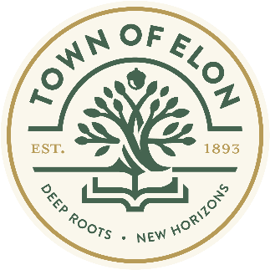
Adopt a Hydrant To Paint
For the artist in all of us

We want to see what your vision of a hydrant can be.
The Town of Elon is seeking the community to submit their designs to paint a fire hydrant in The Town Of Elon. There is an artist in all of us and here is your chance to share your vision. Get your neighborhood, church, youth group or any others interested together and submit a design and which hydrant you would like to paint.
Artists are invited to submit designs for hydrants using their imagination around the theme, “The Past, Present, and Future of Elon.”
Eligibility
- Artists need to be residents of Elon or students at Elon University.

Details

All interested parties should send their completed application to Jill Weston, Downtown Development Director jweston@elon.gov. Along with the completed form, applicants must include a sketch and description of their proposed design.

Application deadline Friday, March 17th 5:00pm

Please schedule your paint day with Jill Weston at jweston@elon.gov
who will give you supplies.

While artists should provide their own brushes, and other painting supplies. Tarps and the paint itself will be provided. Please note: it is an acrylic enamel paint suitable for metal surfaces, and includes a gloss finish. The following colors will be provided: Green, blue, purple, red, yellow, white and black. The Town of Elon will provide the paint.

- Designs must abide by copyright laws; only designs born of applicants' original artwork will be accepted.
- Designs may not include business logos and/or any implied commercial endorsement.
- Designs cannot compromise the visibility of the hydrants.
Criteria:
- Paint only on the assigned fire hydrant.
- The Town will supply the appropriate paint and the artist must paint according to the Fire Department Regulations (this info will be provided to you prior to painting).
- Nothing can be attached to the fire hydrant.
- Artists may use stencils, airbrush with masking tape, or freehand your design.
- Artists must stick to the approved design. If you desire to make changes, you must seek the Town of Elon’s approval prior to changing your design.
- The public and private space immediately around the fire hydrant should be kept clean and neat when not directly working on the fire hydrant. Please respect the property.
- Fire hydrants that become faded and no longer enhance the immediate area will be painted over. For example, a hydrant that begins to peel or otherwise deteriorate.

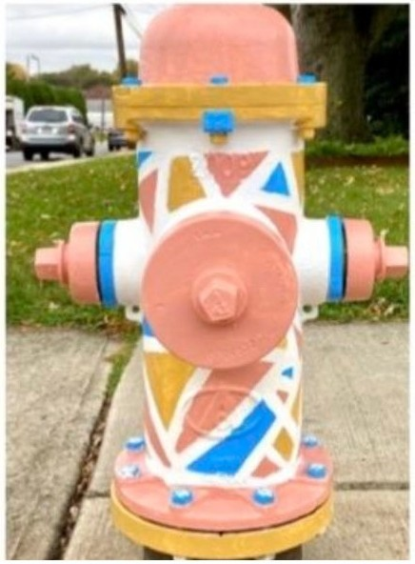
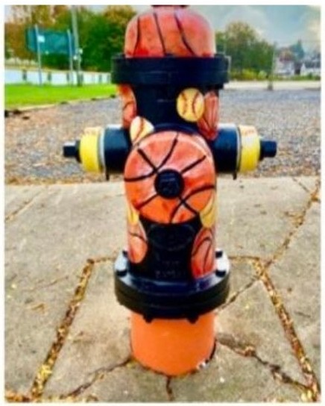

Samples of painted hydrants

Adopt A Hydrant to Paint
For the artist in all of us

Application Information

Name or Organization* ___________________________________________________

Address * __________________________________________________________________

City * _________________________State * ____________ZIP *______________

Email Address * _____________________________________________________________

Phone Number *___________________________________

Location Requested_________________________________________________________

Describe Your Design*

Attach drawing of design and color scheme.

Return to: Jill Weston jweston@elon.gov
Elon Town Hall 104 S. Williamson Ave. Elon NC 27244

